**Day-42 practice (14/10/2024)**

1. Go to AWS

2. create ec2 instance name -

3. AMI - RHEL

4. Instance_type = t3.micro

5. no key pair

6. allow-all security group

7. click on launch instance

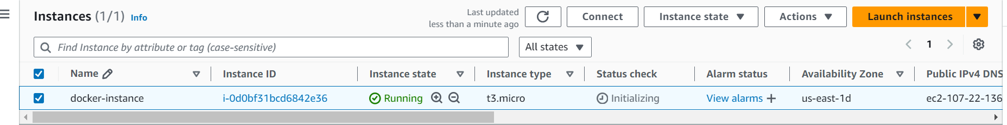

Login to the server and install docker using commands from this link <https://docs.docker.com/engine/install/rhel/>

**we have to install docker**   
1. Open chrome

2. search for docker install - select RHEL

<https://docs.docker.com/engine/install/rhel/>

**steps to install docker**

1. sudo yum install -y yum-utils

2. sudo yum-config-manager --add-repo https://download.docker.com/linux/rhel/docker-ce.repo

3. sudo yum install docker-ce docker-ce-cli containerd.io docker-buildx-plugin docker-compose-plugin

4. sudo systemctl start docker

5. sudo systemctl status docker

6. docker ps -> It works only in root user

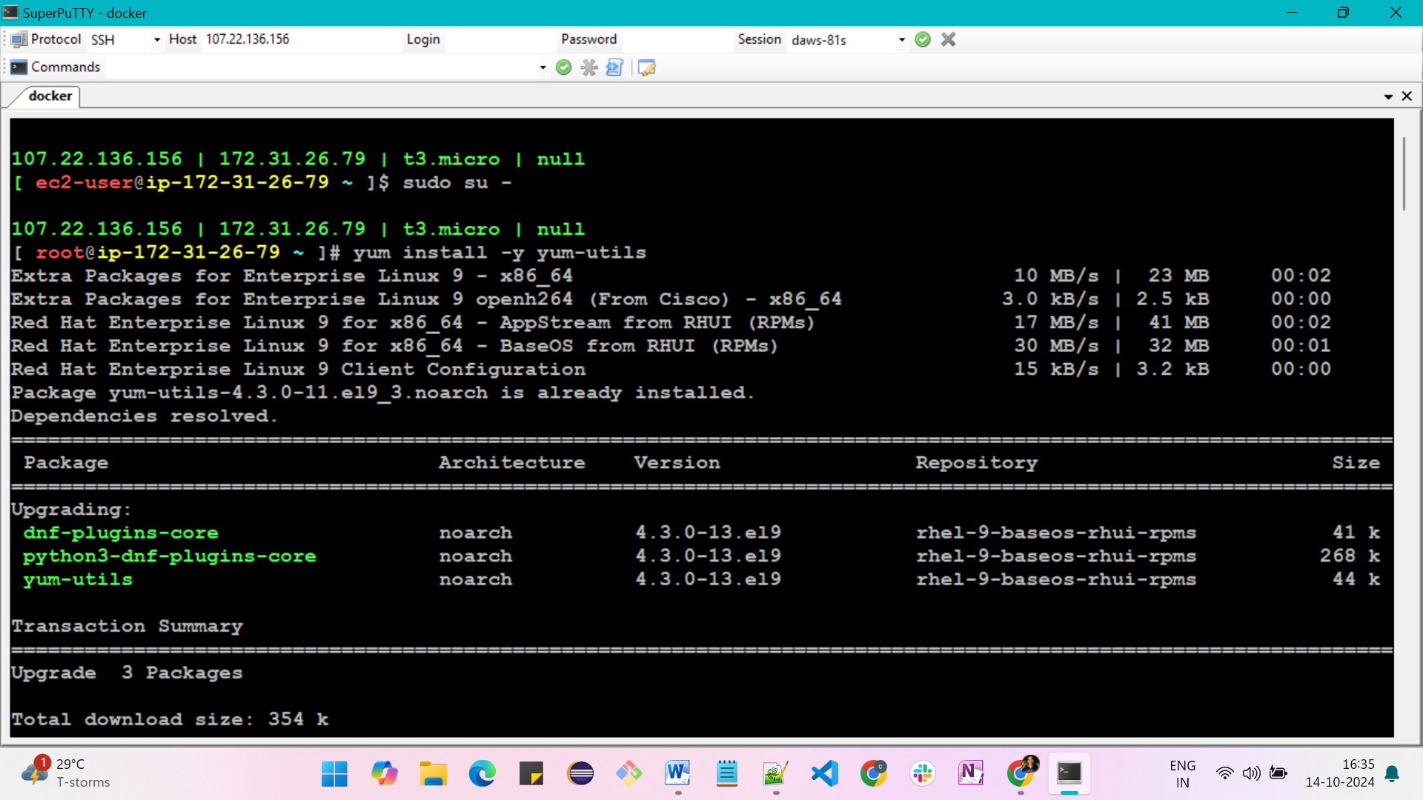

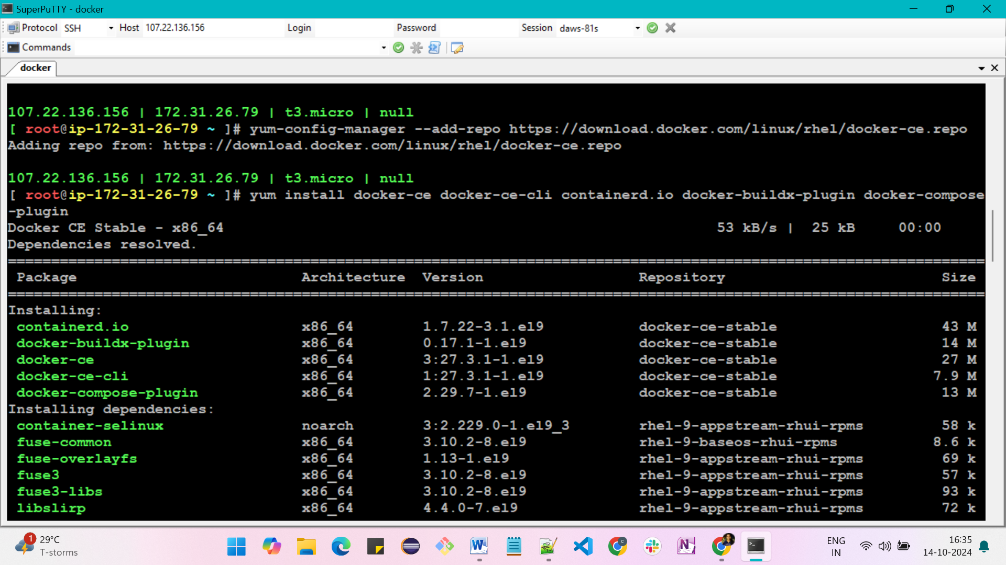

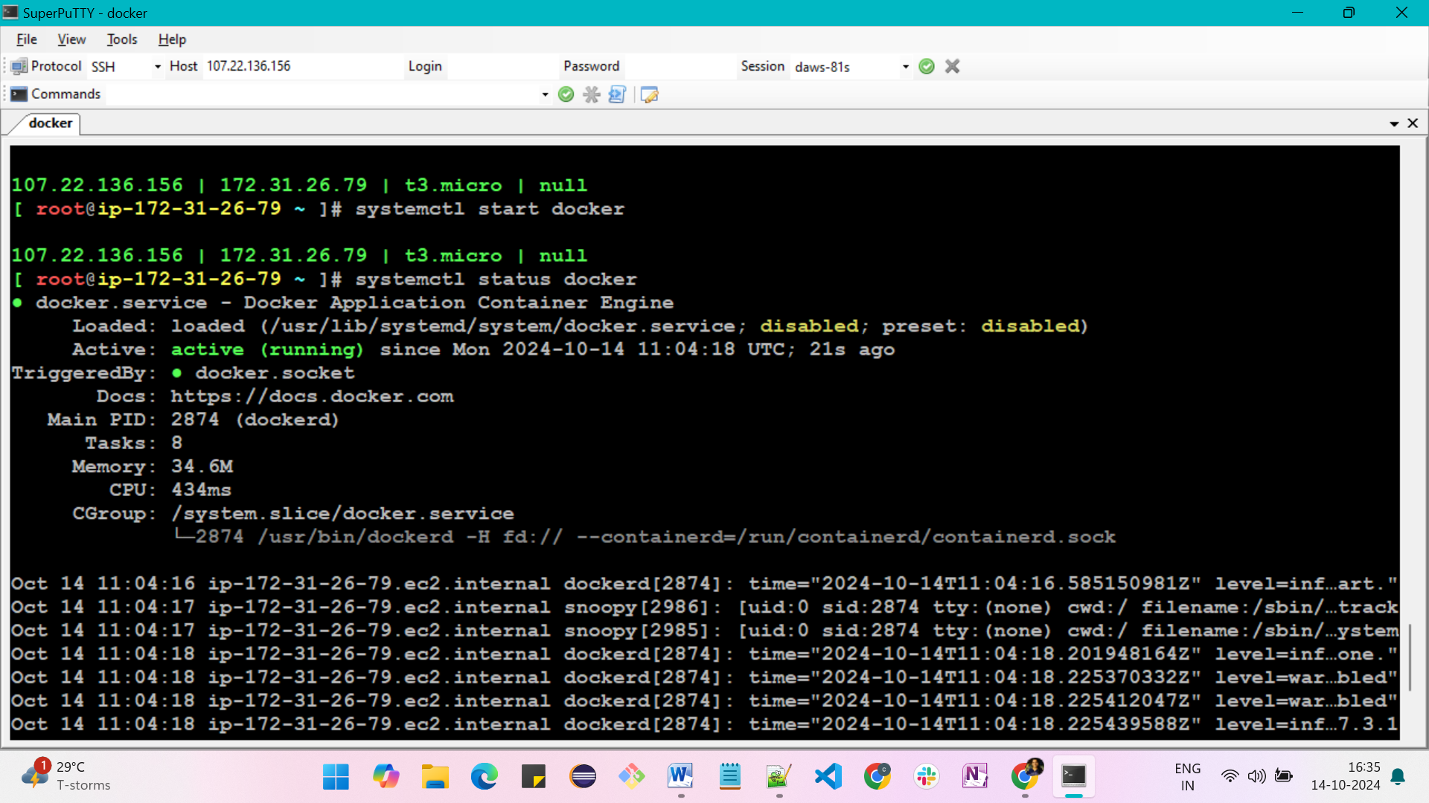

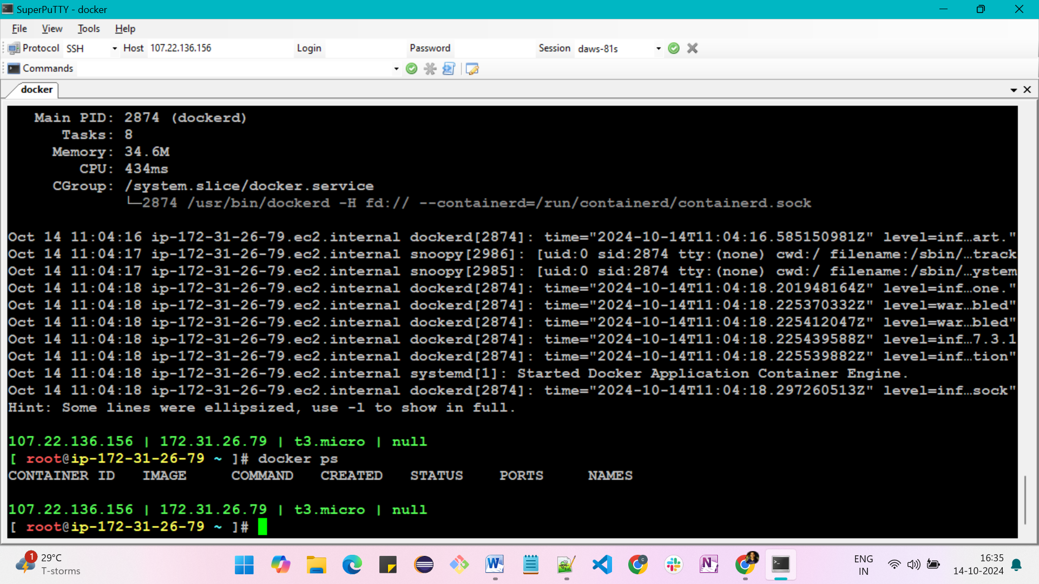

By this approach, we can access the docker commands without root user

* when docker is installed a group called docker is created
* Now, add ec2-user to the docker group
* commands is, sudo usermod -aG docker ec2-user
* It will not get immediately. so once exit and login again to get the effect

1. search for docker hub - https://hub.docker.com/search?q=nginx

2. signup

3. search for nginx

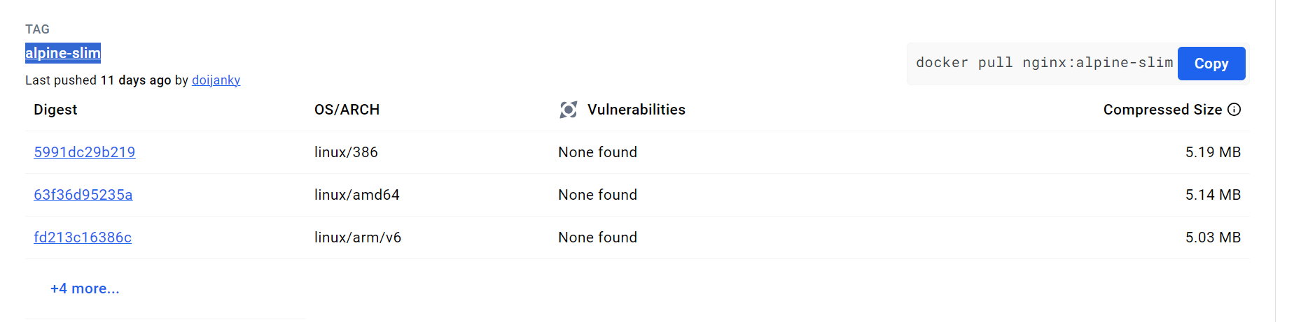

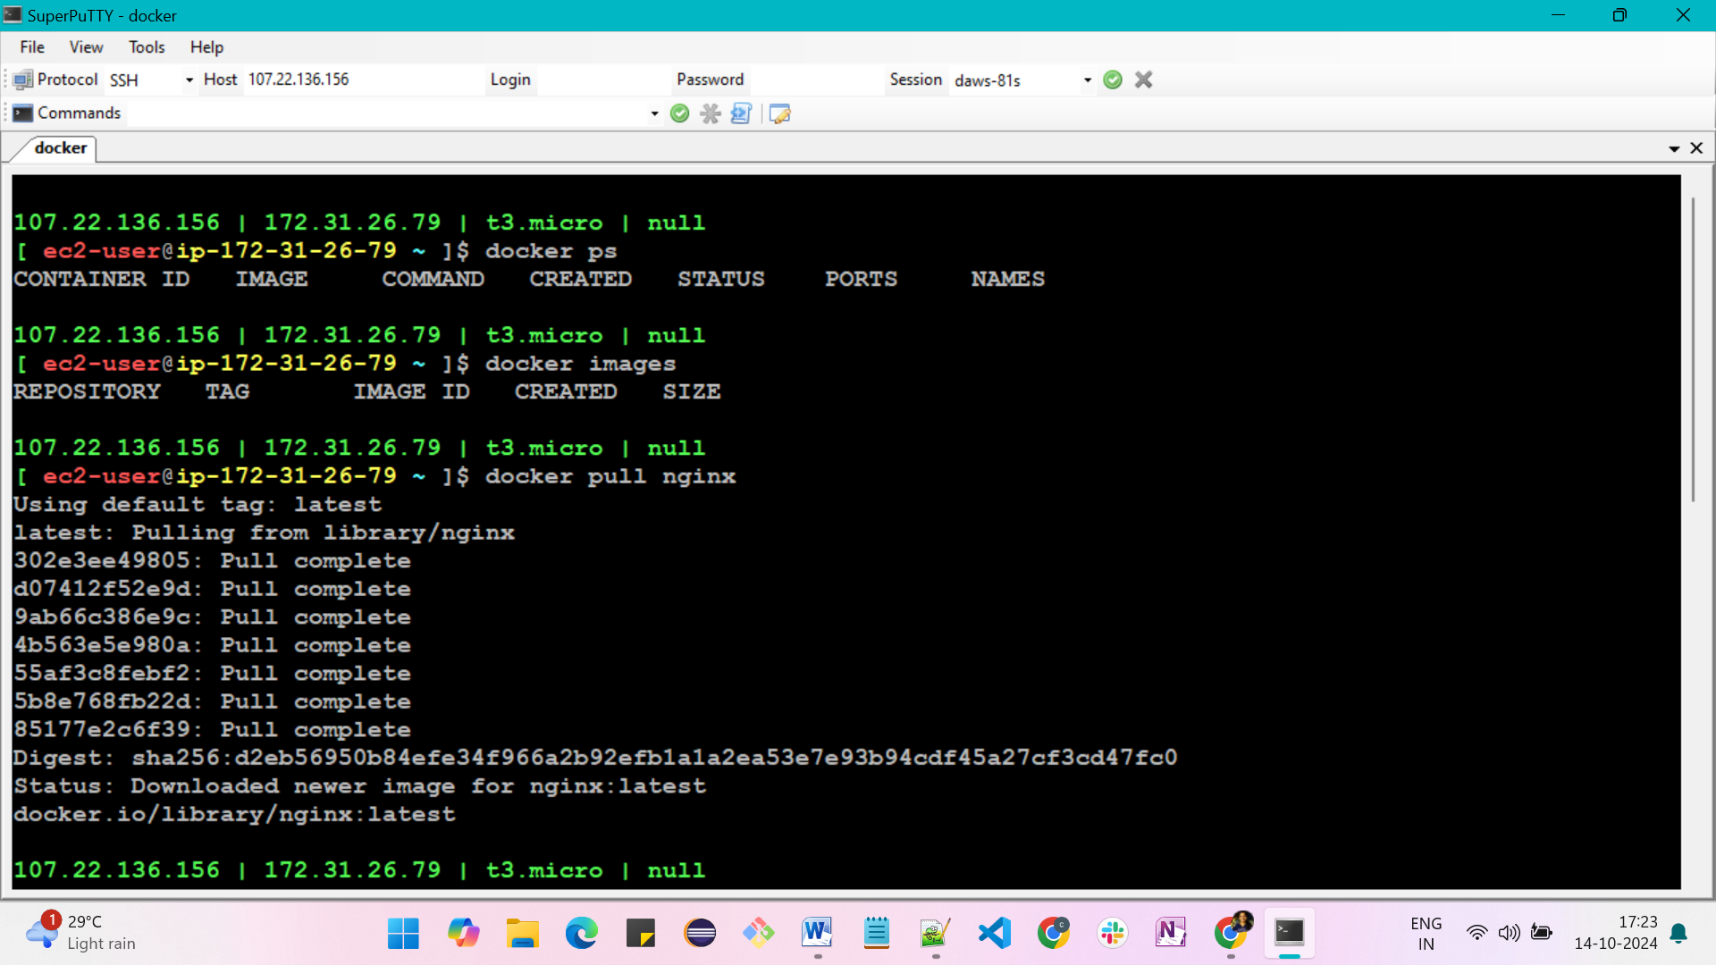

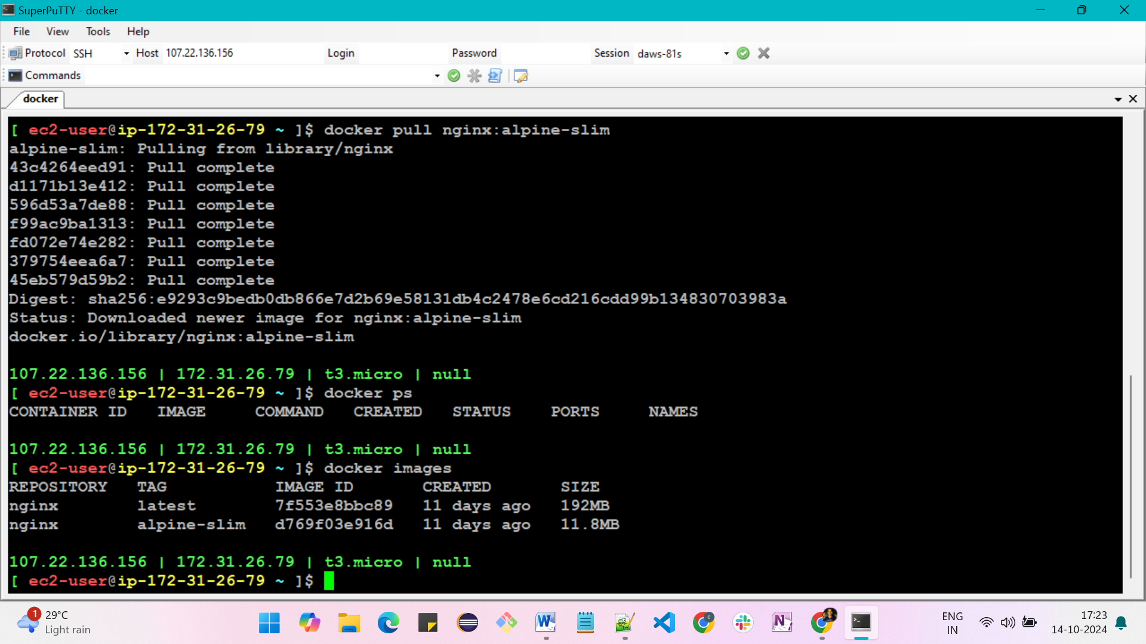

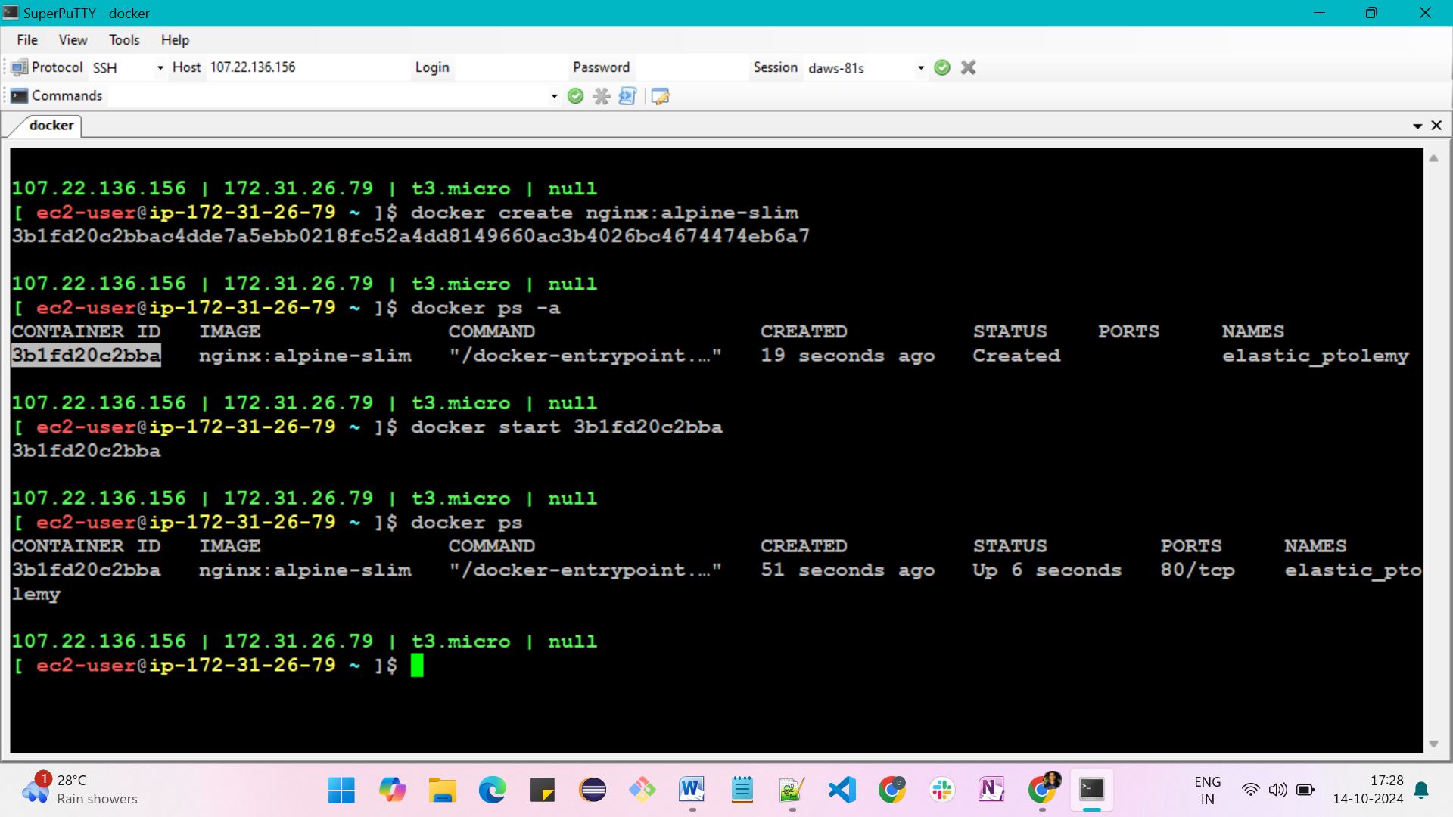

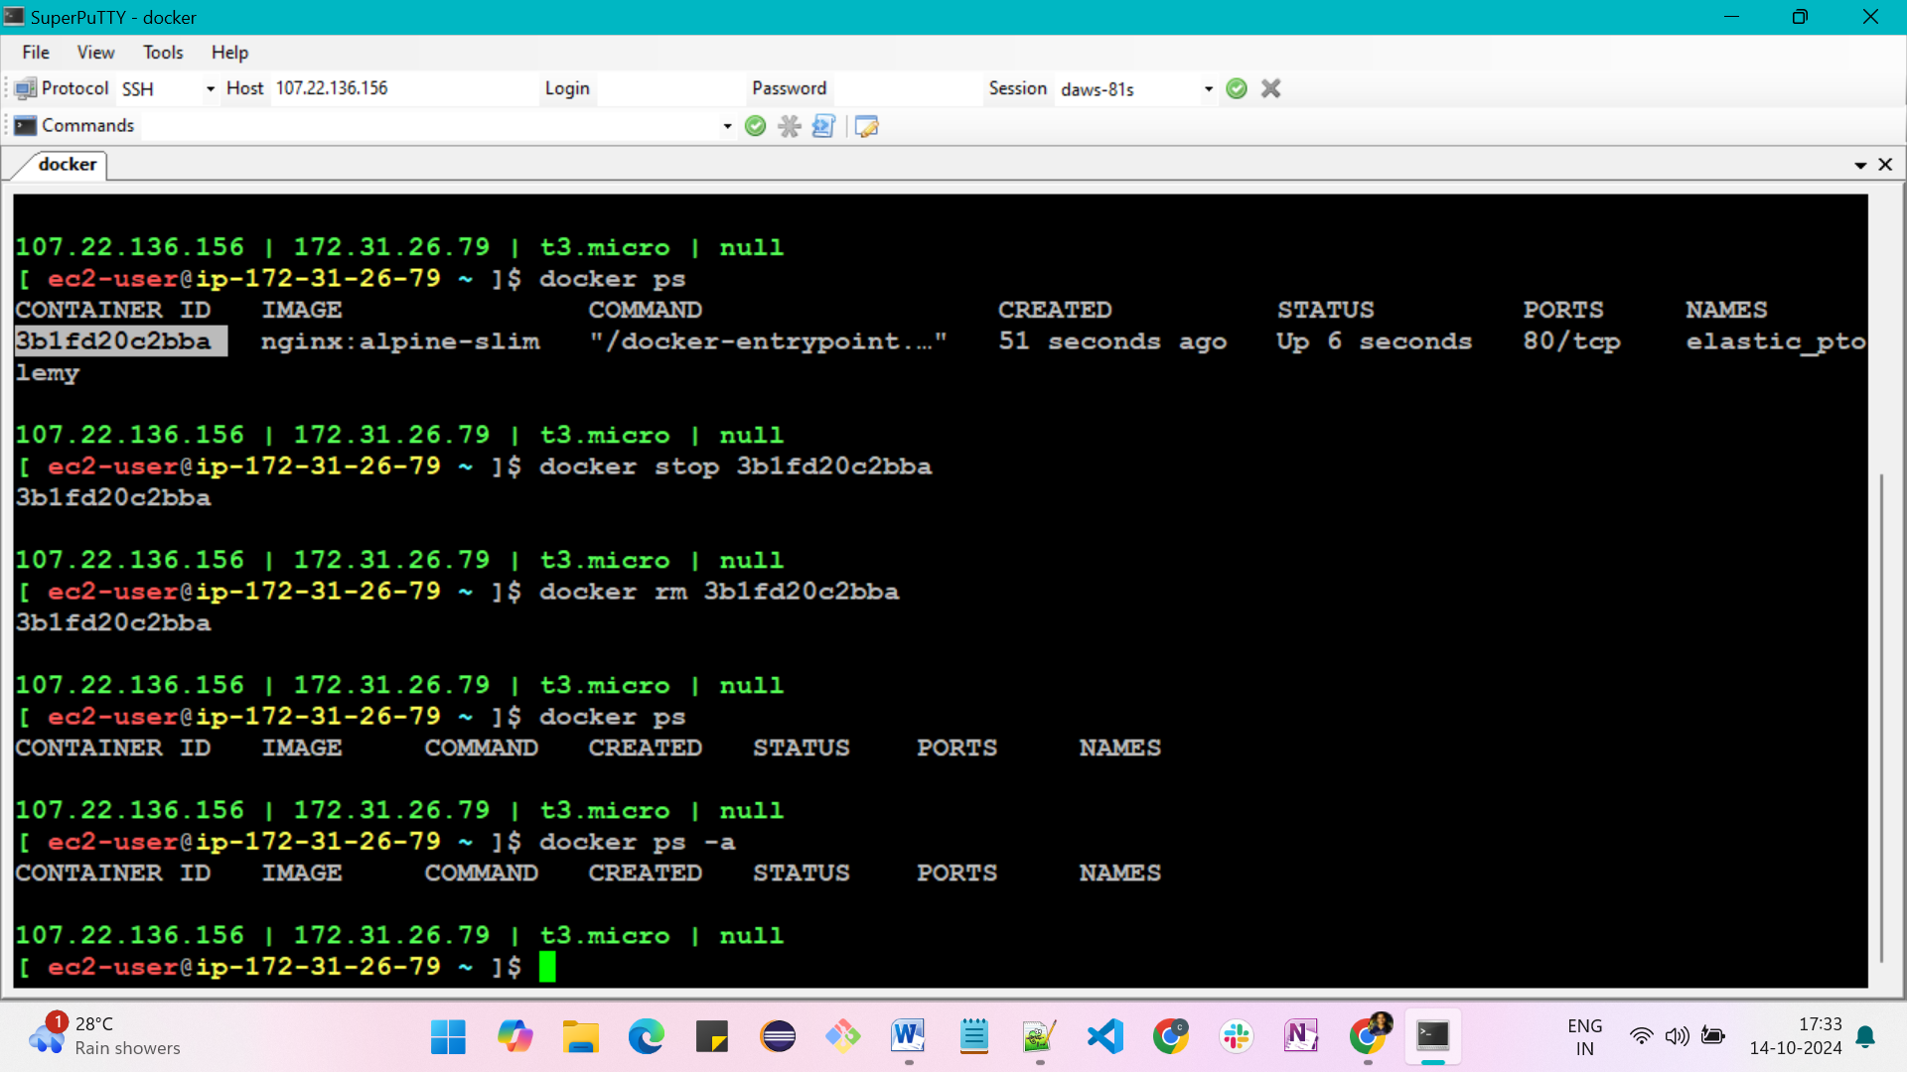

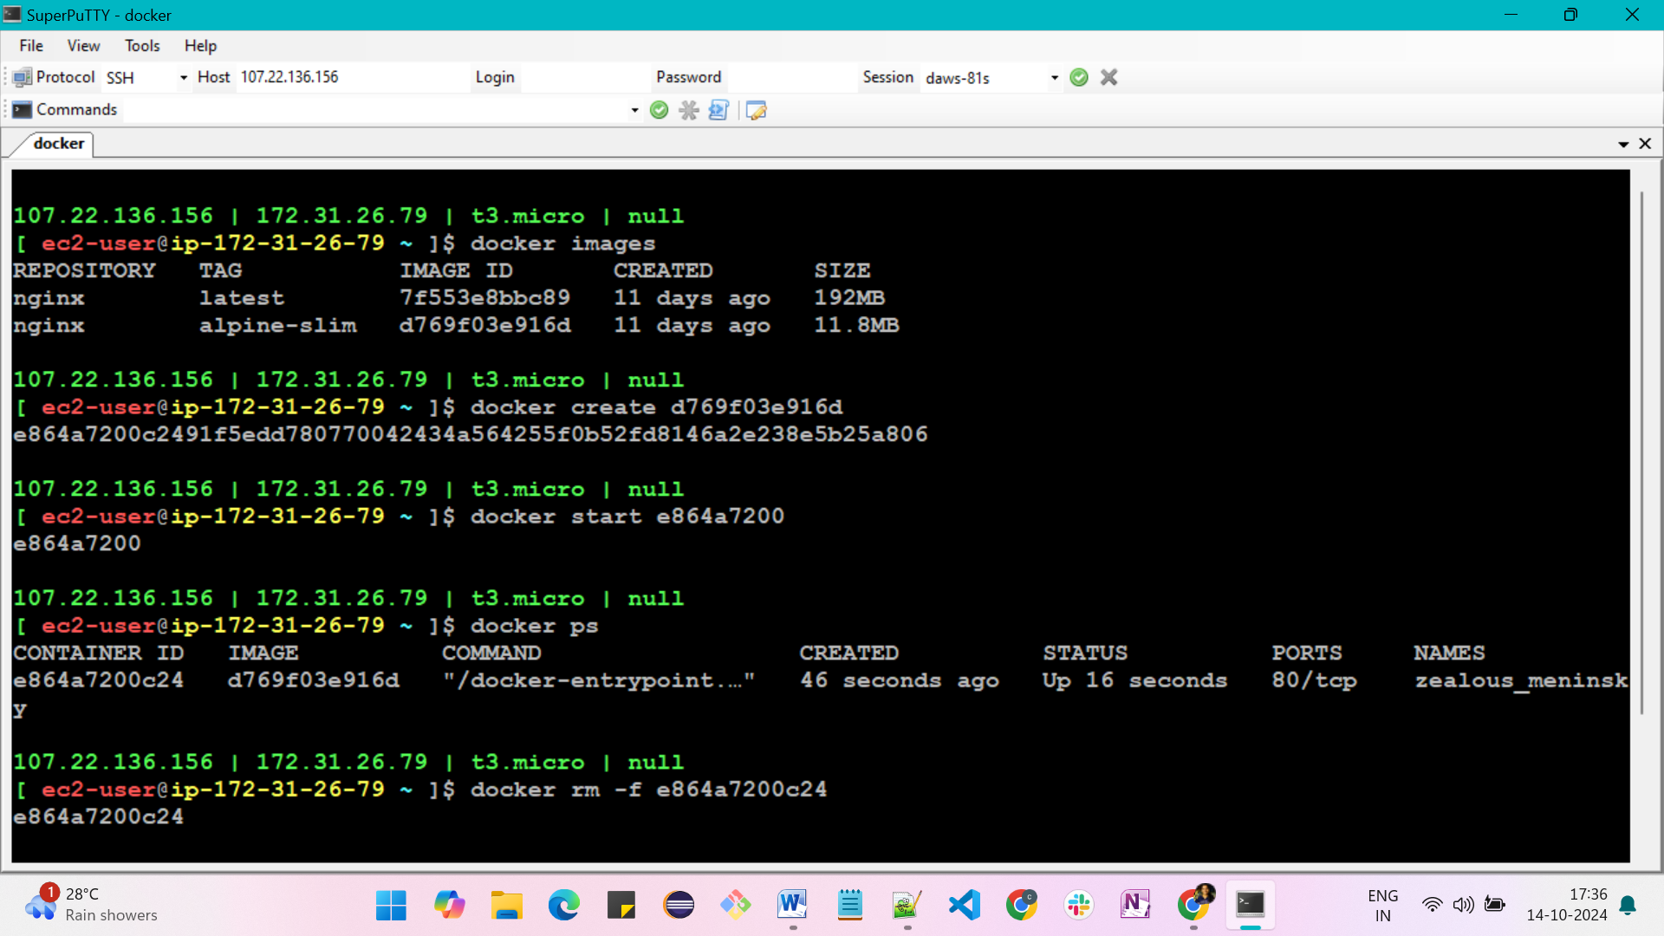

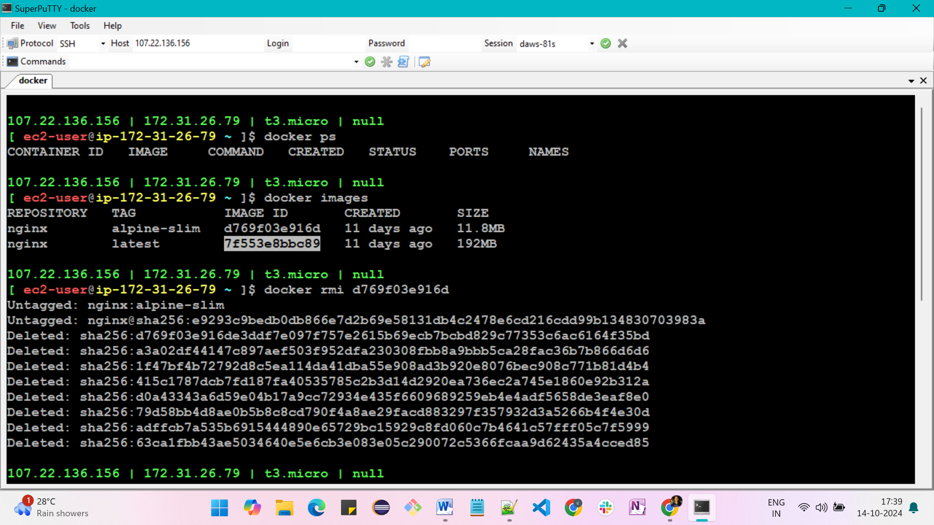

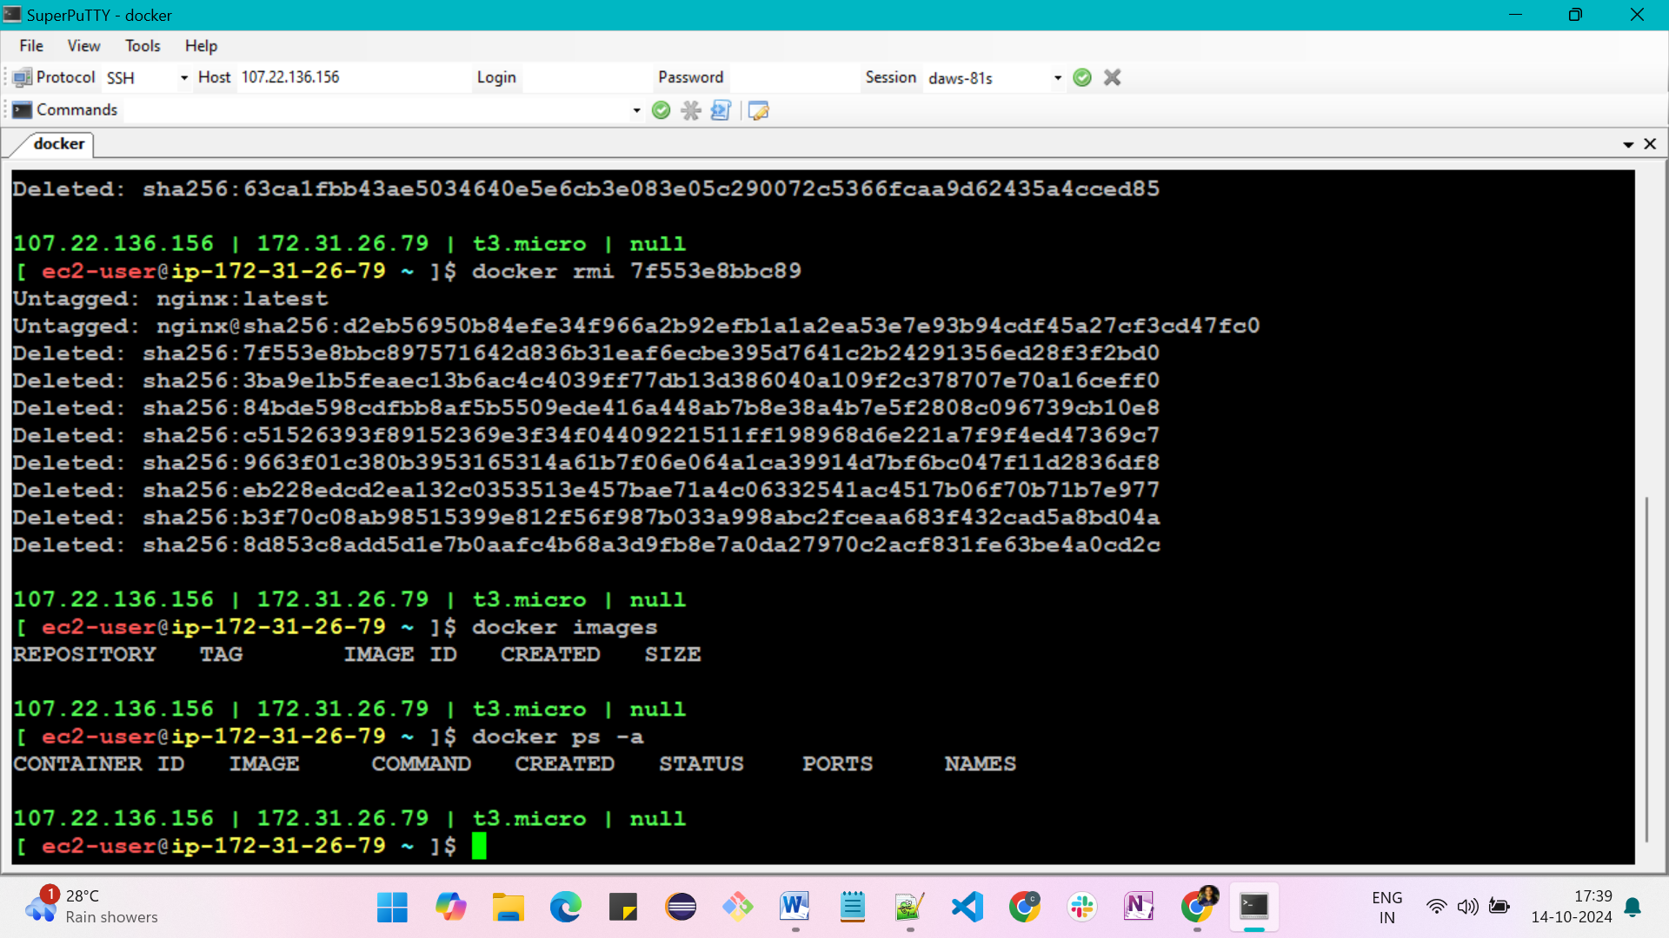

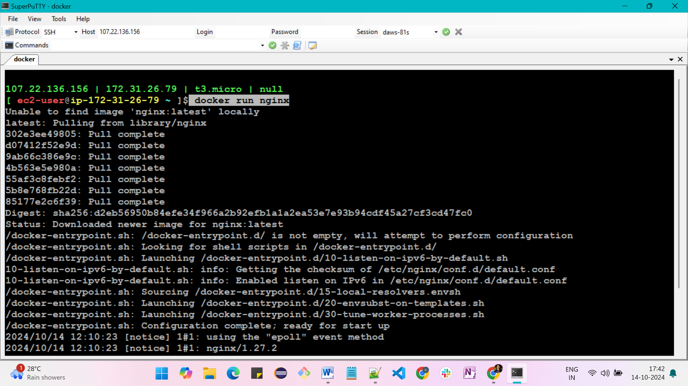

**How do you run the container in the backgroung?**

Use command; **docker run -d nginx**

Here, -d is for detached process

* foreground = attaching to the screen
* -d is for detaching the screen

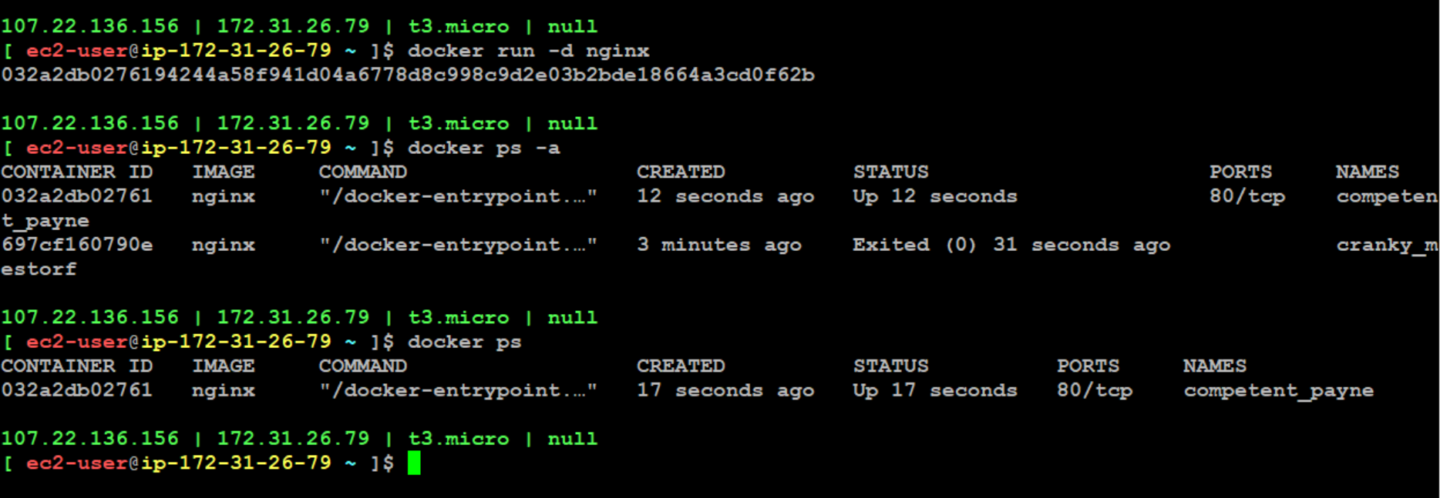

**Now, I have installed container in the VM. Then How can I access it in browser**?

* we have container inside the VM
* when user accesses the server it reaches to the server port
* we have host port and container port
* Container is like a nano/mini server. It also have 0-65,535 ports
* when user hits, first request comes to server called host port
* so, host port is mapped with container port

we use coammand for the above;

**-p <host-port>:<container-port>**

Example;

docker run -d -p 80:80 nginx

docker run -d -p 8080:80 nginx

docker run -d -p 8081:80 nginx

Here, -p is for port forwarding

**How can you open the container in internet?**

By using port forwarding

